Programming with Python1

លំហាត់សម្រាប់ Midterm

Chapter 1 : Basic

1.1- Please create an application to show message like below:

|  |
| --- |
| Welcome to learn Visual Basic.Net Programming Language.  Here is the starting point of this lesion.  Your Register Name is : **Chhom Makara**. |
| Imort java.lang.  If lese |
| Answer: |

1.2- Please create an application that allow user to prompt a string and then show that string as a message. See the example of below:

|  |
| --- |
| Welcome to VB.NET:  What is your name : **Keo Sereyroth**  Your name is : **Keo Sereyroth**  Answer: |

1.3- Please create an application that allow user to prompt any two number and then total it together. At the end of this application show the result as a message. See the example of below:

|  |
| --- |
| Welcome to VB.NET:  Please input number - 1 : **3.5**  Please input number - 2 : **3.5**  The total is : **7**  Answer: |

1.4- Please create an application that allow user to prompt any two number and then let them choose one of the below method:

1 – Summary

2 – Multiply

3 – Minus

After the calculation show the result as a message. See the example of below:

|  |
| --- |
| Please input number - 1 : **2**  Please input number - 2 : **3**  Please choose method below:  1 – Summary  2 – Multiply  3 – Minus  Your choice : **2**  The result is : **6**  Answer: |

1.5- Please create an application that allow user to input any score of five subject (Math, Physic, Khmer, Chemistry, and English) and then calculate them as **total** and **average**:

See the example of below:

|  |
| --- |
| Please input five score of subject below :   * Math : **100** * Physic : **100** * Khmer : **100** * Chemistry : **100** * English : **100**   The total is : **500**  The average is : **100**  Answer: |

Chapter 3 Control Structure

3.1- Please create an application to calculate the maximum number of two number:

|  |
| --- |
| Calculate the maximum of two number :  Input Number -1 : **10**  Input Number -2 : **20**  The maximum number is: **20**.  Answer: |

3.2- Please create an application to calculate the maximum and minimum number of any three number:

|  |
| --- |
| Calculate the maximum, minimum of three number :  Input Number -1 : **10**  Input Number -2 : **20**  Input Number -3 : **30**  The maximum number is: **30**.  The minimum number is: **10**.  Answer: |

3.3- Please create an application that allow user input a number of week [1 to 7]. Then translate that number as a word [1: Monday, 2 : Tuesday … 7 : Sunday].

|  |
| --- |
| Please Input a number [1-7] : **2**  Today is: **Tuesday**.  Aswer: |

3.4- Please create an application that allow user input a shortcut of color. Then translate it as a full word of color [R : Red, B : Blue, G : Green, W : White, Y : Yellow].

|  |
| --- |
| Enter a shortcut of color name : **R**  Your favorite color is : **Red**.  Answer: |

3.5- Please create an application that allow user to input a number of score then accumulate it together and print it as average.

|  |
| --- |
| How many score? : **3**  Score - 1 : **10**.  Score - 2 : **20**.  Score - 3 : **30**.  ===========================  The sum = **60**  The avg = **20**  Answer: |

3.6- Please using [loop] to writing code to show result like below.

|  |
| --- |
| Answer: |

2.7- Please using [loop] to writing code to show result like below.

|  |
| --- |
| **************  **************  **************  Answer: |

3.8- Please using [loop] to writing code to show result like below.

|  |
| --- |
| *  **  ***  ****  Answer: |

3.9- Please using [loop] to writing code to show result like below.

|  |
| --- |
| *  **  ****  ******  Answer: |

3.10- Please using [loop] to writing code to show result like below.

|  |
| --- |
| *  **  ***  **** |

3.11- Please using [loop] to writing code to show result like below.

|  |
| --- |
| *  ***  *****  *******  Aswer: |

3.12- Please using [loop] to writing code to show result like below.

|  |
| --- |
| *  ***  *****  *******  *********  *  *  ***  Answer: |

3.13- Please writing a program to find the square of the numbers from 1 to 100 by using :

- While

- Do … Loop

- For … Next

The output should be below:

|  |
| --- |
| Number Square   1. 1 2. 4 3. 9   …………………  …………………  Answer: |

3.14- Please writing a program to find the ODD/EVEN of the numbers from 1 to 100:

The output should be below:

|  |
| --- |
| 1 is ODD  2 is EVEN  3 is ODD  …………………  …………………  Answer: |

3.15- Please writing a program to show a series of the numbers like below:

|  |
| --- |
| 10 20 30 40 50 60  Answer: |

3.16- Please writing a program to show a series of the numbers like below:

|  |
| --- |
| 60 50 40 30 20 10  Answer: |

3.17- Please writing a program to sum a series of the numbers below **(6pt)**:

a)- sum=1+2+3+….+n = ?

b)- sum=1+3+5+….+n = ?

c)- sum=1+2+4+….+n = ?

d)- sum=12+22+32+….+n2 = ?

e)- sum=12+32+52+….+n2

f)- sum=12+22+42+….+n2

Answer:

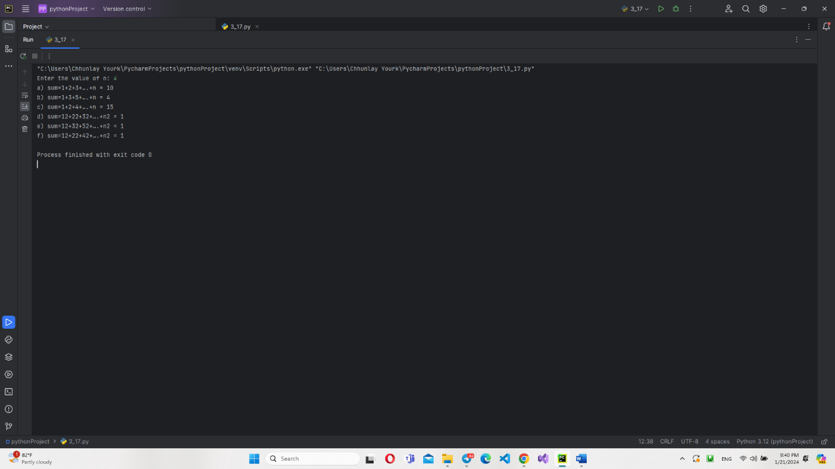

3.17- Please writing a program to generate the following series of the numbers:

|  |
| --- |
| 1  21  321  4321  54321  654321  7654321  87654321  987654321  Answer: |

3.18- Please writing a program to generate the following series of the numbers:

|  |
| --- |
| 1  12  123  1234  12345  123456  1234567  12345678  123456789 |

3.19- Please writing a program to generate the following series of the numbers:

|  |
| --- |
| 987654321  87654321  7654321  654321  54321  4321  321  21  1  Answer: |

3.20- Please writing a program to generate the following series of the numbers:

|  |
| --- |
| 123456789  12345678  1234567  123456  12345  1234  123  12  1  Answer: |

3.21- Please writing a program that print a given number whether it is a prime number or not by using :

- While

- Do … Loop

- For … Next

Hint of prime number below:

|  |
| --- |
| Prime number is a number which is divisible only by 1 and by itself.  3 is a prime number since it is divisible by 1 and 3.  6 is not prime because it is divisible by 1,2 and 3.  Answer: |

3.22- Please writing a program that read a number (n) from the standard keyboard input device, and again read a digit (d) and check whether the digit is present in the number (n) or not, if it is so count how many times it is repeated in the number (n).

For example:

|  |
| --- |
| n=12576  Digits to be checked is 5  The digit is present 1 time.  Answer: |

3.23- Please writing a program that read a number (n) from the standard keyboard input device, and again read a digit (d) and check whether the digit is present in the number (n) or not, if it is so, find out the position of (d) in the number (n).

For example:

|  |
| --- |
| n=75689  Digits to be checked is 5   1. is present at the position 4 from left to right. 2. Answer: |

3.24- Please writing a program that read a position number (n) and generate the following form.

For example:

|  |  |
| --- | --- |
| Enter a number : 5  Output : 54321012345 | Enter a number : 7  Output : 765432101234567 |
| Answer: |  |

3.25- Please writing a program to generate following pyramid of numbers:

For example:

|  |
| --- |
| 0  101  21012  3210123  432101234  54321012345  6543210123456  Answer: |

3.26- Please writing a program to solve a general quadratic equation: (aX2+bX+c=0) **(4pt)**

Algorithm:

|  |
| --- |
| Variable float a,b,c,x,x1,x2,beta;  Enter the value a,b and c;  1)- Special Case  If a=0 then  x1=x2= -c / a;  End if  2)- Normal Case  Beta=b2 - 4ac;  If (beta<0) then “No Root”;  Else  If (beta=0) then  x = -b/(2a);  else  x1=(-b-sqrt(beta))/(2a);  x2=(-b+sqrt(beta))/(2a);  end if  Answer: |

3.27- Please writing a program that let user input score of a subject and generate a grade of the score whether is A, B, C, D, E, or F.

Algorithm:

|  |  |
| --- | --- |
| Score Range | Grading |
| 100-91 | A |
| 81-90 | B |
| 71-80 | C |
| 61-70 | D |
| 50-60 | E |
| <50 | F |

At the end of program ask user to restart the action, if user choose [no] exit the program.

For Example:

|  |
| --- |
| Please enter a score : **50**  Your grade is : **E**  Would you like to continue[y/n] ? : **y**  Please enter a score : **100**  Your grade is : **A**  Would you like to continue[y/n] ? : **n**  **Good bye!**  **Answer:** |

3.28- Please writing a program to solve and discuss the equation:

aX+aY=m

cX+aY=n

Asnwer:

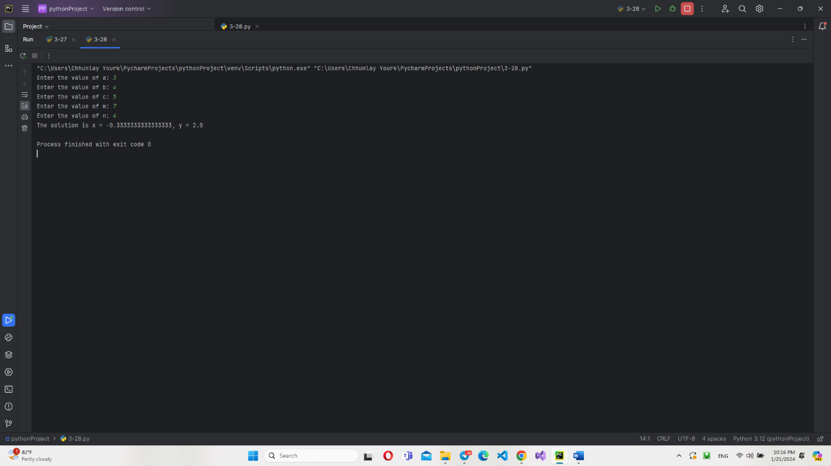

3.29- Please writing a program to calculate the fee of bicycle ticket base on condition below:

|  |
| --- |
| - before 17:00 the fee is 100r/hour  - after 17:00 the fee is 200r/hour  Answer: |

3.30- Please writing a program to calculate the selling price for customer of the Godden Rice Shop. The base price is 1200r/kg. If customer buy rice between 100kg to 500kg they get discount 15%, if they buy over 500kg they will get discount 25% off.

For example:

|  |
| --- |
| The weight of rice : **50**  Selling Price : **60000**  Would you like to continue[y/n] ? : **y**  The weight of rice: **100**  Selling Price : **(1200*100)-(1200*100)*15/100**  Would you like to continue[y/n] ? : **n**  **Good bye!**  **Answer:** |

3.31- Please writing a program to calculate the **tax on salary** of a staff for ABC Company. The program can be test many time.

|  |  |  |
| --- | --- | --- |
| **Monthly salary (Riels)** | **Rate** | **Syntax of Calculation** |
| 0 - 500,000 | 0% | 0 |
| 500,001 - 1,250,000 | 5% | Tax on Salary=(Salary X 5%) - 25000 |
| 1,250,001 - 8,500,000 | 10% | Tax on Salary=(Salary X 10%) - 87500 |
| 8,500,001 - 12,500,000 | 15% | Tax on Salary=(Salary X 15%) – 512500 |
| 12,500,001 - upwards | 20% | Tax on Salary=(Salary X 20%) - 1137000 |
| Answer: |  |  |

3.31- Please writing a program to calculate the Insurance Wage on salary of a staff for ABC Company. The program can be test many time.

|  |  |
| --- | --- |
| **Monthly Wage (Riel)** | **Assumed Wage (Riel)** |
| Below 200,000 | 200,000 |
| 200,001-250,000 | 225,000 |
| 250,001-300,000 | 275,000 |
| 300,001-350,000 | 325,000 |
| 350,001-400,000 | 375,000 |
| 400,001-450,000 | 425,000 |
| 459,001-500,000 | 475,000 |
| 500,001-550,000 | 525,000 |
| 550,001-600,000 | 575,000 |
| 600,001-650,000 | 625,000 |
| 650,001-700,000 | 675,000 |
| 700,001-750,000 | 725,000 |
| 750,001-800,000 | 775,000 |
| 800,001-850,000 | 825,000 |
| 850,001-900,000 | 875,000 |
| 900,001-950,000 | 925,000 |
| 950,001-1,000,000 | 975,000 |
| 1,000,001 up | 1,000,000 |
| answer |  |

3.32- Please writing a program to calculate the Exchange Money from Dollar to Riel. The program can be test many time.

For example:

|  |
| --- |
| Please Enter Dollar : **50**  Please Enter Exchange Rate : **4000**  Exchange Money Dollar to Riel is : **200000**  Would you like to continue[y/n] ? : **y**  Please Enter Dollar : **10**  Please Enter Exchange Rate : **4000**  Exchange Money Dollar to Riel is : **40000**  Would you like to continue[y/n] ? : **n**  **Good bye!**  **Answer:** |

3.33- Please writing a program to calculate the Exchange Money from Riel to Dollar. The program can be test many time.

For example:

|  |
| --- |
| Please Enter Riel : **40000**  Please Enter Exchange Rate : **4000**  Exchange Money Riel to Dollar is : **10**  Would you like to continue[y/n] ? : **y**  Please Enter Riel : **400000**  Please Enter Exchange Rate : **4000**  Exchange Money Riel to Dollar is : **100**  Would you like to continue[y/n] ? : **n**  **Good bye!**  **Answer:** |

Chapter 4 Method

4.1- Write a program to calculate two input number from keyboard and create function to sum, multiply, division, and minus.

**IPO Chart:**

|  |  |  |
| --- | --- | --- |
| Input | Process | Output |
| Two number  N1,N2 | Get Two numbers  Sum=N1+N2  Minus=N1-N2  Multiply=N1*N2  Division=N1/N2 | Display value of :  Sum  Minus  Multiply  Division |
| Answer: |  |  |

4.2- Write a program to accept a number (N) from keyboard and create function to calculate the factorial value.

**IPO Chart:**

|  |  |  |
| --- | --- | --- |
| Input | Process | Output |
| Input N | Get N  Fact=N!=N*(N-1)*….*1 | Display Fact; |
| answer |  |  |

4.3- Write a program to accept a number (N) from keyboard and create function to find out (N) is ODD or EVEN.

**IPO Chart:**

|  |  |  |
| --- | --- | --- |
| Input | Process | Output |
| Input N | Get N  If N Mod 2=0 Then  Print EVEN  Else  Print ODD  End If | Display ODD/EVEN; |
| Answer: |  |  |

4.4- Write a program to accept two number from keyboard and create method to print out the maximum value.

**IPO Chart:**

|  |  |  |
| --- | --- | --- |
| Input | Process | Output |
| Input N1,N2 | Get N1,N2  Find Max | Display Max; |
| Answer: |  |  |

4.5- Write a program to accept three number from keyboard and create method to print out the maximum and minimum value.

**IPO Chart:**

|  |  |  |
| --- | --- | --- |
| Input | Process | Output |
| Input N1,N2,N3 | Get N1,N2,N3  Find Max  Find Min | Display Max;  Display Min; |
| Answer: |  |  |

4.6- Write a program to accept five number from keyboard and create method to print out the maximum and minimum value.

**IPO Chart:**

|  |  |  |
| --- | --- | --- |
| Input | Process | Output |
| Input N1,N2,N3,N4,N5 | Get N1,N2,N3,N4,N5  Find Max  Find Min | Display Max;  Display Min; |
| Answer: |  |  |

4.7- Write a program to accept a number from keyboard and create **recursive function** to find out the factorial value.

**IPO Chart:**

|  |  |  |
| --- | --- | --- |
| Input | Process | Output |
| Input N | Get N  Calculate Factorial | Display Factorial; |
| Answer: |  |  |

4.8- Write a program to accept a number from keyboard and create **recursive function** to calculate the series of value like below:

1. Sum = 1+2+3+….+N
2. Sum = 1+3+5+…+N
3. Sum = 1+2+4+…+N
4. Mul = 1*2*3*……*N
5. Answer: 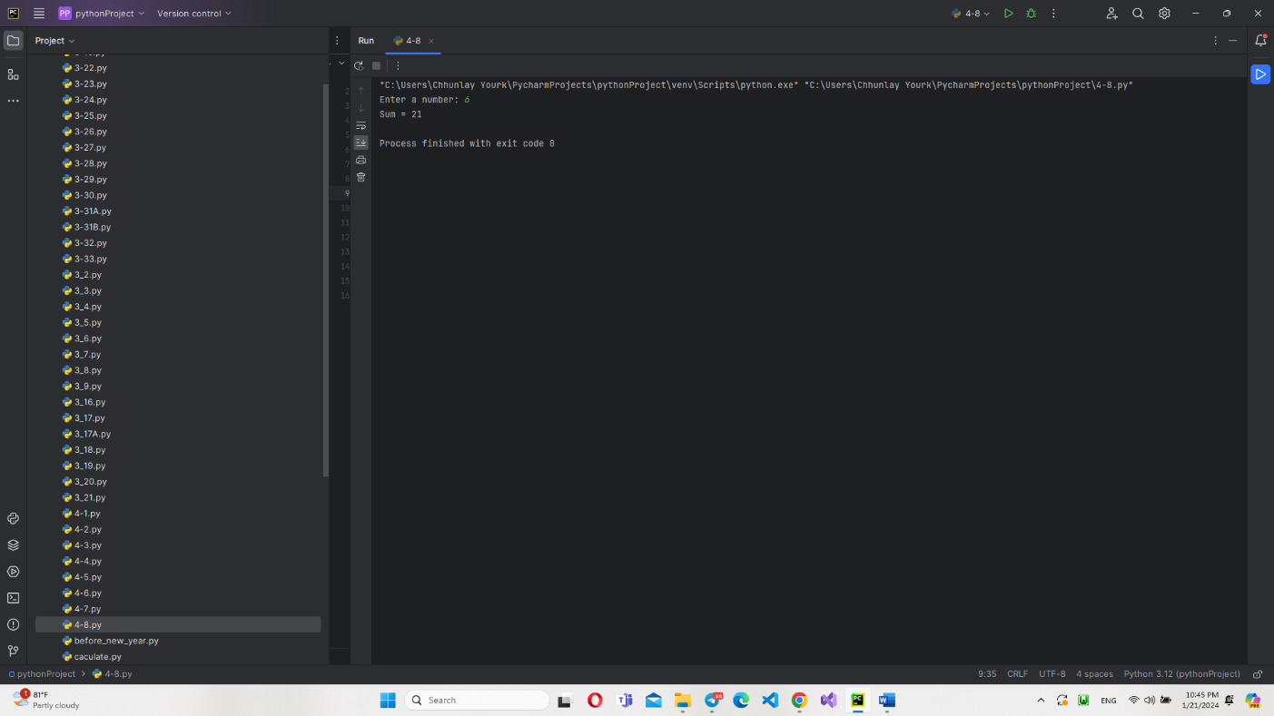

4.9- Write a program to accept five score from keyboard then print out the average value by using method.

**IPO Chart:**

|  |  |  |
| --- | --- | --- |
| Input | Process | Output |
| Input Score1,Score2,Score3,Score4,Score5 | Get five score  AVG=(Score1+…+Score5)/5 | Display AVG; |
| Answer: |  |  |

4.10- Write a program to accept five score from keyboard then print out the **grade** status by using method.

Algorithm:

|  |  |
| --- | --- |
| Score Range | Grading |
| 100-91 | A |
| 81-90 | B |
| 71-80 | C |
| 61-70 | D |
| 50-60 | E |
| <50 | F |
| Answer: |  |

**IPO Chart:**

|  |  |  |
| --- | --- | --- |
| Input | Process | Output |
| Input Score1,Score2,Score3,Score4,Score5 | Get five score  AVG=(Score1+…+Score5)/5  Generate Grade | Print Grade; |

4.11- Write method to find the cube of any three number.

**IPO Chart:**

|  |  |  |
| --- | --- | --- |
| Input | Process | Output |
| Input N1,N2,N3 | Get 3 Number  Calculate Cube | Display Cube; |
| Answer: |  |  |

4.12- Write method to find the area of circle.

**IPO Chart:**

|  |  |  |
| --- | --- | --- |
| Input | Process | Output |
| Input PI,R | Get PI,R  Calculate Circle Area=PI*R2  (PI=3.14) | Display Circle Area; |
| Answer: |  |  |

4.13- Write method to swap two data items.

**IPO Chart:**

|  |  |  |
| --- | --- | --- |
| Input | Process | Output |
| Input N,M | Get N,M;  Display N,M;  Swap N<->M; | Display N,M; |
| Answer: |  |  |

4.14- Write method to calculate the exchange money from Dollar to Riel.

**IPO Chart:**

|  |  |  |
| --- | --- | --- |
| Input | Process | Output |
| Input Dollar, ExchangeRate | Get Dollar, ExchangeRate;  Riel=Dollar * ExchangeRate | Display Riel |
| Answer: |  |  |

4.15- Write method to calculate the exchange money from Riel to Dollar.

**IPO Chart:**

|  |  |  |
| --- | --- | --- |
| Input | Process | Output |
| Input Riel, ExchangeRate | Get Riel, ExchangeRate;  Dollar=Riel / ExchangeRate | Display Dollar |
| Answer: |  |  |

4.16- **ABC MFI** is a Micro Finance Institute that provide the loan to customer. Please write method to generate monthly payment like table below.

|  |  |  |  |  |
| --- | --- | --- | --- | --- |
| **តារាងការប្រាក់ដែលអតិថិជនត្រូវបង់រំលស់** | | | | |
| **ប្រាក់ខ្ចី(Borrow Money)** | | $ 8,000.00 |  |  |
| **អត្រាការប្រាក់(Interest Rate)** | | 1.5 |  |  |
| **Duration(Month)** | | 12 |  |  |
| **ខែទី (mm)** | **ប្រាក់ដើម (Bal)** | **ការប្រាក់ត្រូវបង់ (IR)** | **ប្រាក់ដើមរំលស់ (Dbal)** | **ប្រាក់ត្រូវបង់ (Pay)** |
| 1 | $ 8,000.00 | $ 120.00 | $ 666.67 | $ 786.67 |
| 2 | $ 7,333.33 | $ 110.00 | $ 666.67 | $ 776.67 |
| 3 | $ 6,666.67 | $ 100.00 | $ 666.67 | $ 766.67 |
| 4 | $ 6,000.00 | $ 90.00 | $ 666.67 | $ 756.67 |
| 5 | $ 5,333.33 | $ 80.00 | $ 666.67 | $ 746.67 |
| 6 | $ 4,666.67 | $ 70.00 | $ 666.67 | $ 736.67 |
| 7 | $ 4,000.00 | $ 60.00 | $ 666.67 | $ 726.67 |
| 8 | $ 3,333.33 | $ 50.00 | $ 666.67 | $ 716.67 |
| 9 | $ 2,666.67 | $ 40.00 | $ 666.67 | $ 706.67 |
| 10 | $ 2,000.00 | $ 30.00 | $ 666.67 | $ 696.67 |
| 11 | $ 1,333.33 | $ 20.00 | $ 666.67 | $ 686.67 |
| 12 | **$ 666.67** | $ 10.00 | $ 666.67 | **$ 676.67** |

**IPO Chart:**

|  |  |  |
| --- | --- | --- |
| Input | Process | Output |
| Input **Borrow, Interest, Duration** | Get **Borrow, Interest, Duration**  Dbal = Borrow / Duration | Display **Monthly Payment Table** |
| Month - 1 | Bal_1 = Borrow  IR_1 = (Bal_1 * Interest) / 100  Pay_1 = Dbal + IR_1 |
| Month – 2 to N | Bal_2 = Bal_1 - Dbal  IR_2 = (Bal_2 * Interest) / 100  Pay_2 = Dbal + IR_2 |

Answer